Capturing Adventure on the Go!

[Watch Video](https://www.kingston.com/en/video/play?videoId=FO48bW3KYx9N_wwbQrrbE9VSLmbvIvprot363Dx-macIqL808SVgpep-v0BO7Fo_Y-0L1Gukwq4UWUhSIR3Wjw2&start=0&autoPlay=False&chromeless=False&captionOption=No)

SDCG3

* [Intro](https://www.kingston.com/en/memory-cards/canvas-go-plus-microsd-card#product-features)
* [Specifications](https://www.kingston.com/en/memory-cards/canvas-go-plus-microsd-card#specifications)
* [Product Comparison](https://www.kingston.com/en/memory-cards/canvas-go-plus-microsd-card#comparison-chart-1)
* [Resources](https://www.kingston.com/en/memory-cards/canvas-go-plus-microsd-card#links)
* [Datasheet](https://www.kingston.com/datasheets/sdcg3_us.pdf)

[**Buy**](https://www.kingston.com/en/memory-cards/canvas-go-plus-microsd-card#atc)

Canvas Go! Plus microSD Memory Cardfor Android Mobile Devices, Action Cams, Drones and 4K Video Production

Kingston’s Canvas Go! Plus microSD is for the adventurers who are always on the go chasing the perfect moment to capture. With superior transfer speeds of up to 170MB/s1, the Canvas Go! Plus microSD card accelerates your workflow and efficiency so that you’ll have more time to take your creativity onto the next adventure. With U3 and V30 speed performance, shoot stunning 4K Ultra-HD videos without worrying about slow speeds and dropped frames or shoot fast-action photos that’s seamless and consistent. The Canvas Go! Plus microSD supports A2 Application Performance Class to expedite your workflow with faster application performance on smartphones and tablets. There is an optional SD adapter for added versatility to use with SD compatible devices. View the world as your canvas and take your creativity and inspiration on the road with the Canvas Go! Plus microSD.

* Superior transfer speeds up to 170MB/s1
* Ideal for action cameras, drones and Android devices
* U3 & V30 speed performance
* Supports A2 app performance class
* Durable

Key Features

Superior speeds

Transfer and capture content faster in Full HD & 4K UHD with transfer speeds up to 170MB/s.1

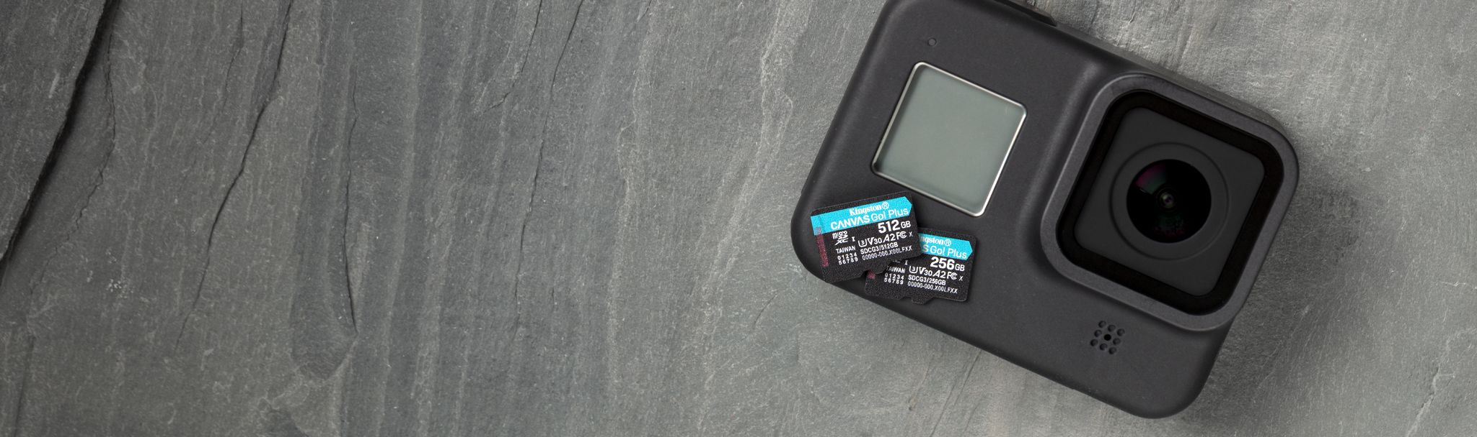

Ideal for action cameras and drones

High-speeds with UHS Speed Class 3 (U3) & Video Speed Class 30 (V30) ratings.



Supports A2 app performance class

Expedite your workflow with faster application performance.

Capacity

 64GB

 128GB

 256GB

 512GB

 1TB

Adapter

 SD Adapter

 None

* Part Number: SDCG3/64GB
* Up to 170MB/s Read, 70MB/s Write

[**Where to Buy**](https://www.kingston.com/en/wheretobuy)

Compare microSD Cards

SDCS2

SDCG3

SDCE

SDCIT2



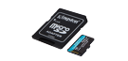

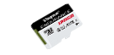

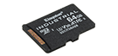

Name

Canvas Select Plus microSD

Canvas Go! Plus microSD

High-Endurance microSD

Industrial microSD

User

Consumer

Consumer

Consumer

Business/ Industrial

Capacity

64GB–512GB

64GB-1TB

32GB–256GB

8GB–64GB

Speed

100MB/s Read (64GB-128GB)  
100MB/s Read, 85MB/s Write (256GB-512GB)

•170MB/s read, 70MB/s write (64GB)  
•170MB/s read, 90MB/s write (128GB-1TB)

95MB/s Read, 30MB/s Write (32GB-64GB)  
95/MB/s Read, 45MB/s Write (128GB-256GB)

Up to 100MB/s Read, 80MB/s Write

Compatibility

UHS-I, U1, V10, A1 (64GB-128GB) UHS-I, U3, V30, A1 (256GB-512GB)

UHS-I, U3, V30, A2

UHS-I, U1, V10, A1

UHS-I Speed Class U3, V30, A1

Usage

• Point and shoot cameras  
• Android devices

• 4K Video Production  
• Action Cameras  
• Drones  
• Android Devices

• Dash cameras  
• Security cameras  
• Body cameras

• Designed and tested to be durable in extreme temperatures

[Learn more](https://www.kingston.com/en/memory-cards/canvas-select-plus-microsd-card)

[Learn more](https://www.kingston.com/en/memory-cards/canvas-go-plus-microsd-card)

[Learn more](https://www.kingston.com/en/memory-cards/high-endurance-microsd-card)

[Learn more](https://www.kingston.com/en/memory-cards/industrial-grade-microsd-uhs-i-u3)